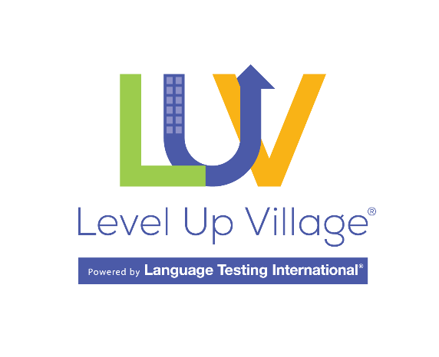
Dear [enter name]
I am seeking funding to offer the students at [your school] an amazing opportunity to participate [number] Level Up Village exchanges with my students on the topic of [insert exchange topic(s)]. Below is some information about Level Up Village to help you decide if you can support this enrichment program for our students.
Level Up Village (LUV) was founded in 2012 as an educational technology enterprise with the mission of facilitating global collaborative STEAM learning for students 4-13 years old. In 2019, LUV joined Language Testing International, and expanded into intercultural exchanges for World Languages students as well as global citizenship exchanges for Social Studies classes. Each exchange provides engaging content, use of a brand-new platform, and the partnership with a teacher in another country.
Exchange Topics: Science, Literature, Social Studies, and Languages & Culture. Please use this link to see the exchanges offered. levelupvillage.com/courses/
How it works: LUV pairs two classrooms in two different countries to engage in hands-on projects or discuss globally important topics that are age-appropriate and relevant to students’ learning. Students exchange teacher-approved videos asynchronously through the secure platform.
Global Partners: LUV works with teachers in the U.S. and pairs them with teachers in schools, NGOs, and learning centers on every continent except Antarctica.
Commitment: Students and teachers spend approximately 1 to 2 hours per week engaged in the exchange, which includes students’ sharing of videos through the platform. The exchanges generally last about 8 weeks. Many of them have flexible start and end dates.
Security: Level Up Village has earned the COPPA Safe Harbor Certification through Privo. LUV will promptly process your school or district Data Privacy Agreement if needed. You can submit it to: support@levelupvillage.com.
Cost: In 2023, the cost per classroom (up to 30 students) for U.S. classrooms is $600 per exchange for STEAM and Social Studies, and $300 for Languages & Cultures. For sources of funding for this kind of program, LUV has put together this information: levelupvillage.com/finding-funding-for-luv-virtual-exchanges/
Communications: LUV is happy to provide you with a fact sheet and information about its exchanges for any press releases, district or school blog posts, school webinars, or family information events.

Benefits to students
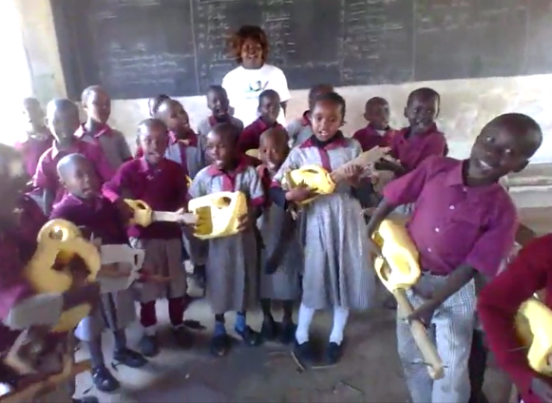
In addition to subject-matter learning, students will build skills in:
- Intercultural communication.
- Global citizenship.
- Collaboration, creativity, and problem solving.
- Critical thinking and presentation of ideas.
- Responsible decision-making.
- Self- and social-awareness, empathy.

Benefits to our school
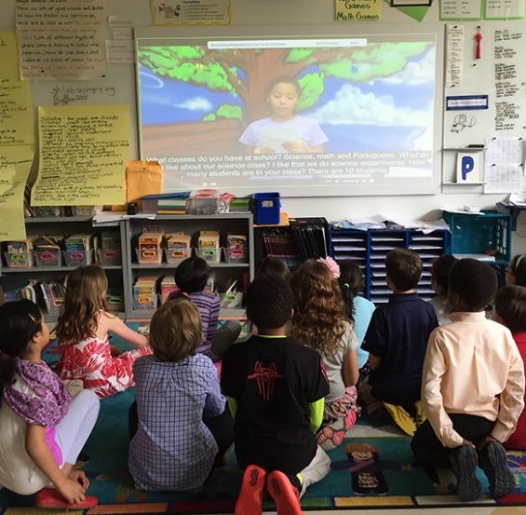
We will:
- Extend our professional networks outside our school and district.
- Leverage collaborative technologies to enhance our students’ learning about the wider world.
- Take advantage of LUV professional development and resources.
- Inspire our students to learn about the world and appreciate other cultures.
- Meet our program’s diversity and inclusion goals.

To learn about Level Up Village, please visit www.levelupvillage.com. The LUV team is happy to demo the platform and courses to our community. Their contact information is as follows:
levelupvillage.com/contact/
Phone: (203) 357-5271
Thank you for your consideration.
[your name here]

